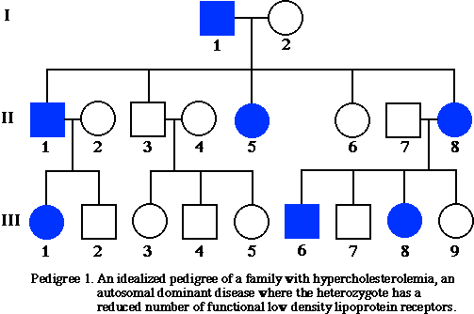**PEDIGREE #1**

1. What kind of inheritance pattern is being tracked in the pedigree to the right?
2. List two pieces of evidence that support your claim.
3. Will individuals II3 and II4 ever have a child that has the trait being tracked? Explain.
4. What is the probability that individuals II7 and II8 have another child that has the trait?

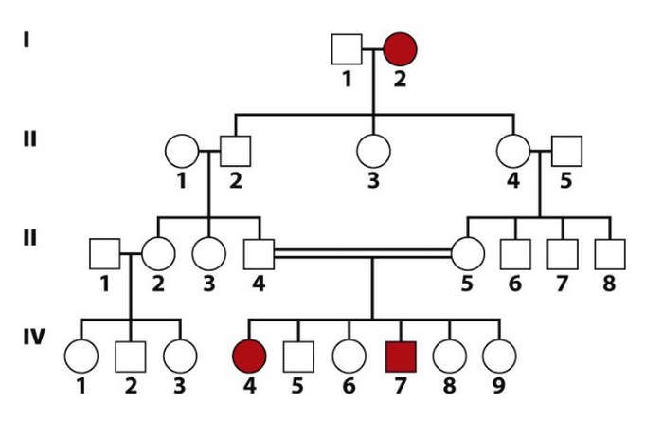**PEDIGREE #2**

1. What kind of inheritance pattern is being tracked in the pedigree to the right?
2. List two pieces of evidence that support your claim.
3. What is the genotype of individuals I2, IV4, and Iv5? ___________
4. What is the genotype of individuals III4 and III5? ___________
5. If individual IV4 has children with a man who is heterozygous for the trait, what is the probability that their child will have the trait?

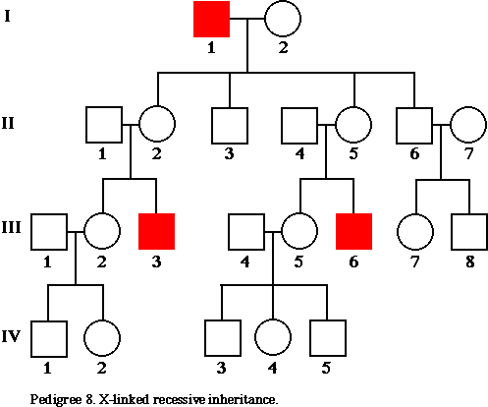

**PEDIGREE #3**

1. What kind of inheritance pattern is being tracked in the pedigree to the right?
2. List two pieces of evidence that support your claim.
3. What is the probability that individual III4 and III5 will have a fourth child with the trait?
4. If individual III3 has a child with a woman who is heterozygous for the trait, what is the chance that they will produce a child with the trait?

**PRACTICE DRAWING A PEDIGREE**

A woman without cystic fibrosis, whose father had the disorder and whose mother did not, marries a healthy man whose parents did not have the disorder. They have a son who is has cystic fibrosis. Draw a pedigree showing all four grandparents, the two parents, and the son. Label the generations and each individual. Indicate each individual’s genotype/possible genotype.

1. If the son from the previous pedigree has children with a woman who is heterozygous, what are the chances of having two healthy children in a row?